**Spring boot & Hibernate & Spring Security**

# **Introduction to Spring boot | Its Advantage over Spring MVC and Servlet:**

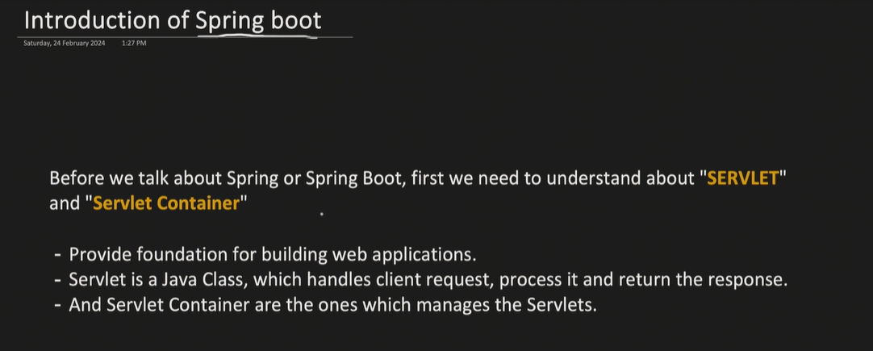

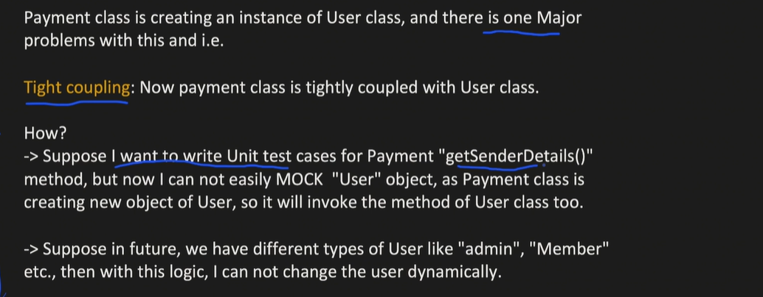

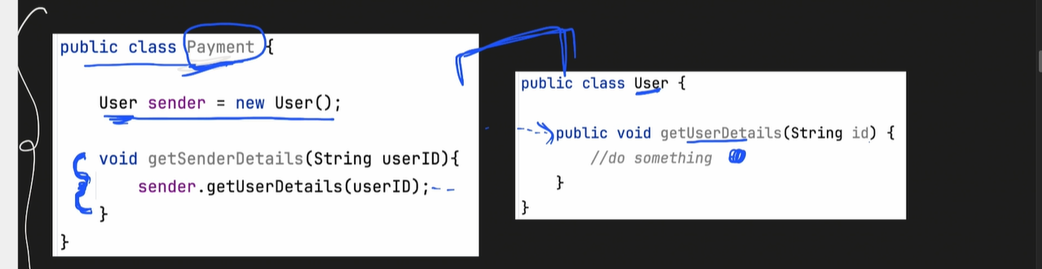

Dependenyc Injection is the solution for the above tight coupling problem

## **Spring MVC Model:**

How we move out from Servlet to Spring MVC

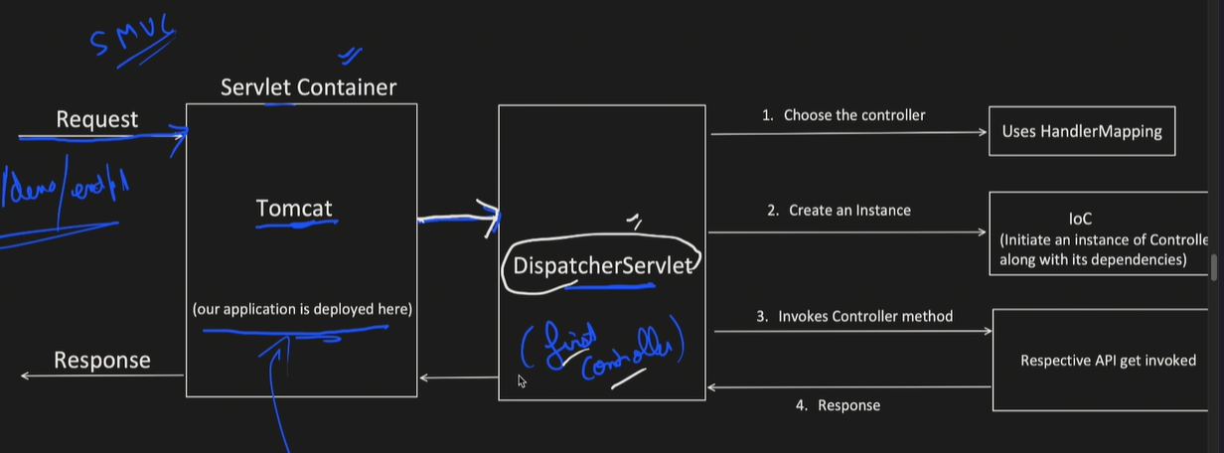

Dispatcher servlet is the first controller which will take the request and match the pattern in out controller class and redirect the request towards that class

**Spring MVC Project Outlook and drawback**

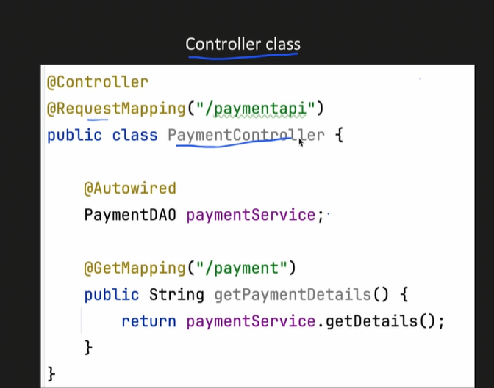

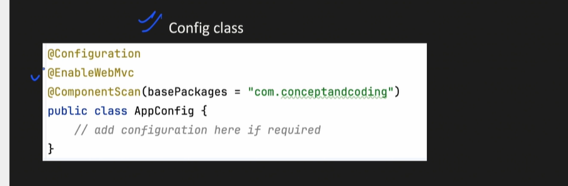

**@EnableMVC loads lot of dependency to run the projects**

**In spring Mvc we have to create Dispatcher servlet to route the request to appropriate controller class below is the code for the same.   
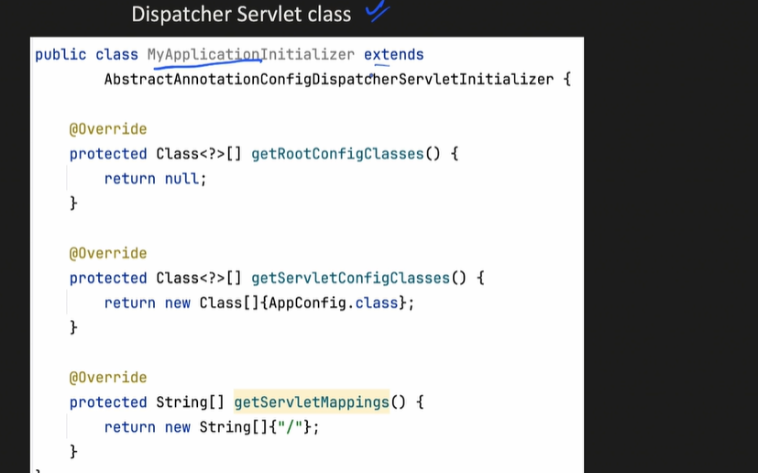**

## **Spring MVC To Spring Boot**:

Springboot solves the dependency management where we don’t need to provide the version in pom.xml

* We just have to give dependency internally it will load the compatible version of the same.
* 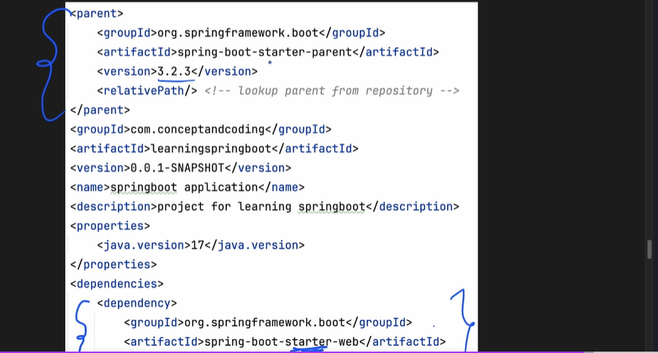
* Autoconfiguration we have in SPRING BOOT as we have seen above the in AppConfig class we have write so many annotation in Spring boot we just need **@SpringBootApplication**
* Embedded server we get in Spring boot We don’t need to configure the server any where

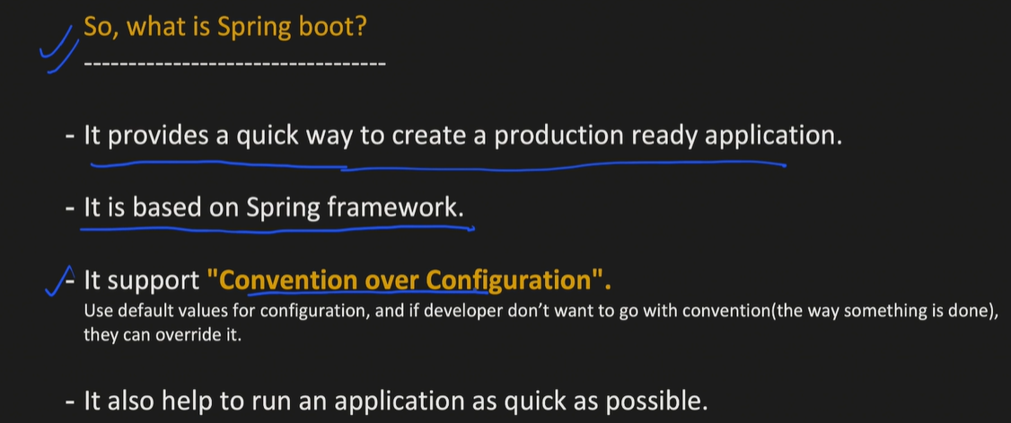

# **Spring boot Project setup and Layered Architecture Introduction**

Stand alone application we will create JAR

WAR when we create a bundle of application we have JS, HTML, CSS and all.

## Layered Architecture of Spring Boot;

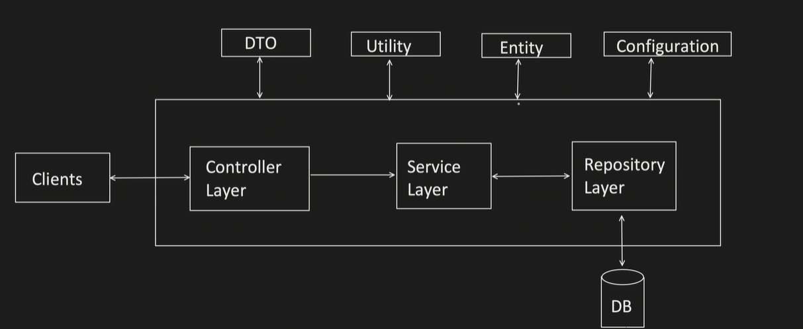

# **Introduction to Maven and its Lifecycle | Spring boot Maven project:**

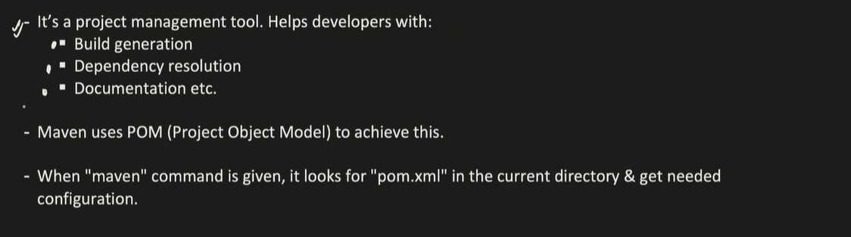

#Commands:

* Mvn Install

## Read Pom.xml File :

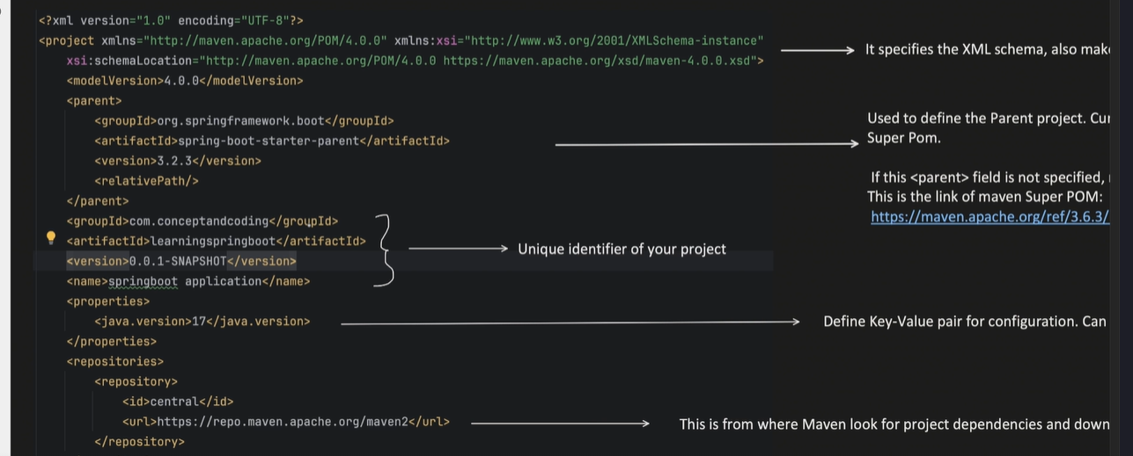

<Project> It should adhere to the rules of schema

Below is the maven build life cycle:

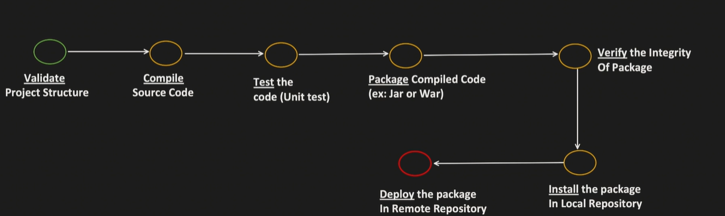

If we need to add the goals at the time of maven build then we will define that in

<build>

<plugins>

<plugin></plugin>

</plugins>

</build>

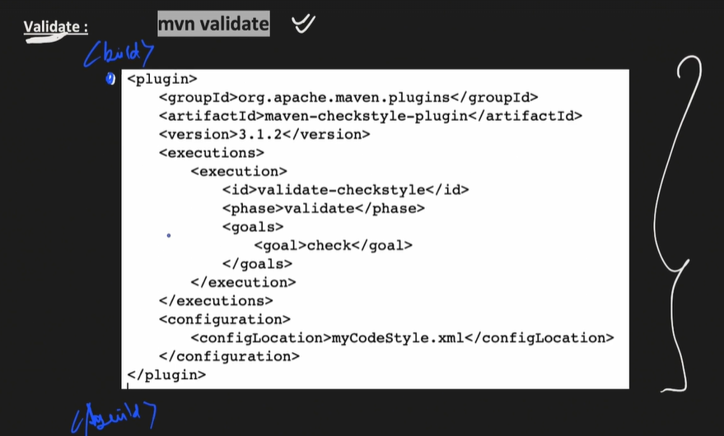

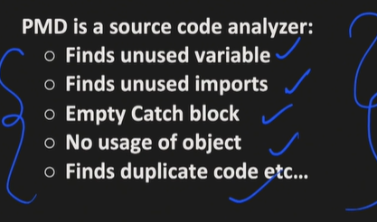

Mvn install -> will install the packages we have in our local repository which is nothing but getting a executable jar file

Mvn Deploy -> will deploy the jar from local repository to remote repository(Central/ Company/ repos).

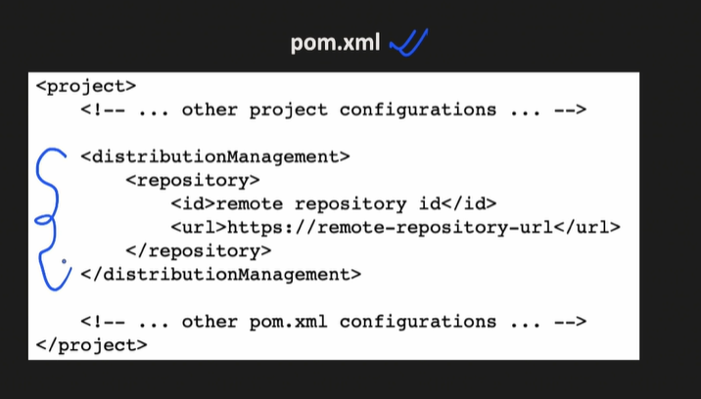

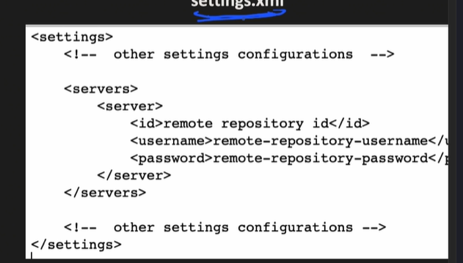

**Setting.xml has the company repo username and password where we need to deploy the jar to remote repository**

# **Spring boot: Bean and its Lifecycle | Inversion of Control (IOC)**

## **Beans:**

Bean is a java obj which is managed by IOC,

IOC Container contains all the bean which get created and managed the life cycle.

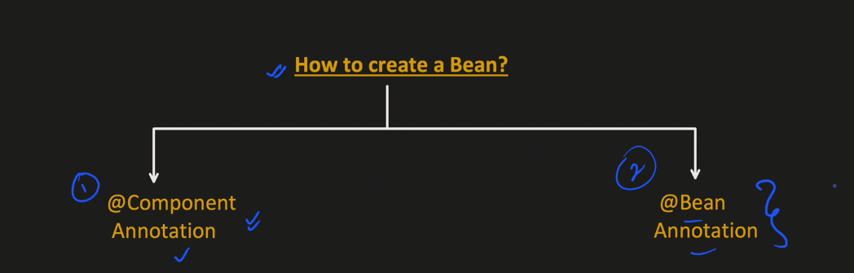

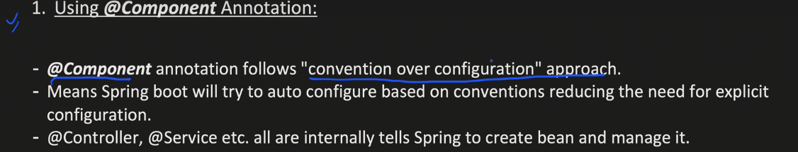

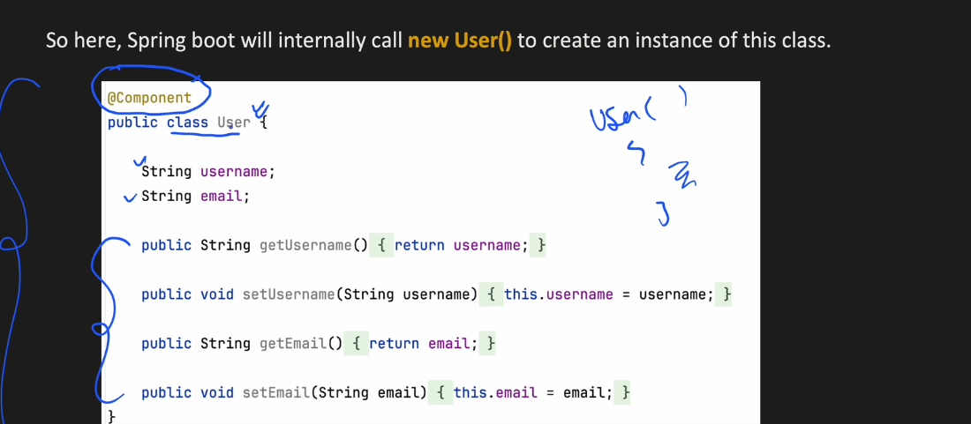

Let say if We use Spring annotation @Component on USER Class

& I have create a code   
@Bean

Public User createUser(){  
return new User(“”,””);

}  
  
So Spring will give us the priority of our own configuration first then the AutoConfiguration.

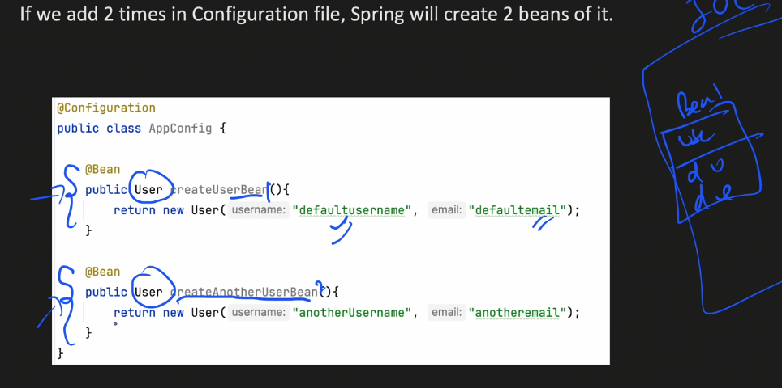

**How Spring Boot Find these Beans ……….?**

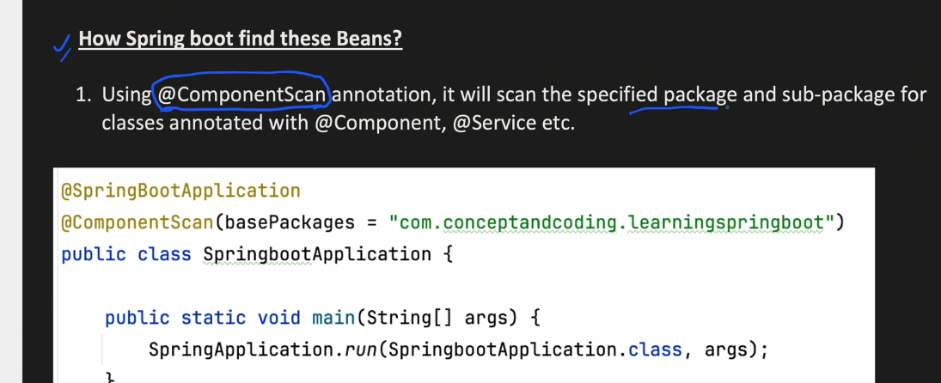

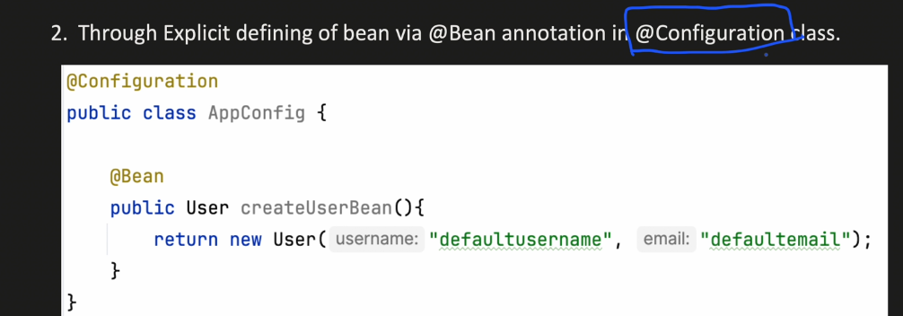

## **Life Cycle Of A Bean:**

## 

4th Step Inject Dependency using constructed Bean Let say we have class With @Configuration of User Class and we have a depency of a Account class then it will create the bean of that class.

# Dependency Injection:

1. Field Injection
2. Setter
3. Constructor injections

## Field Injections:

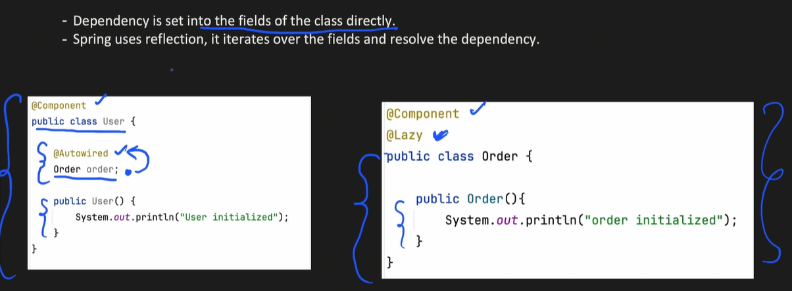

IOC Will Look for Stereotype Annotation and create the Object.

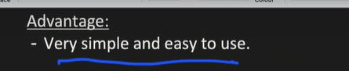

Disadvantage:

1. Can not be used with Immutable Fields

@Autowired  
private final Order order: we will get error !!  
As we know spring uses reflection and iterate over all the fields and look for @Autowired Annotation and it will create the order object without looking any thing and break the immutable principle.

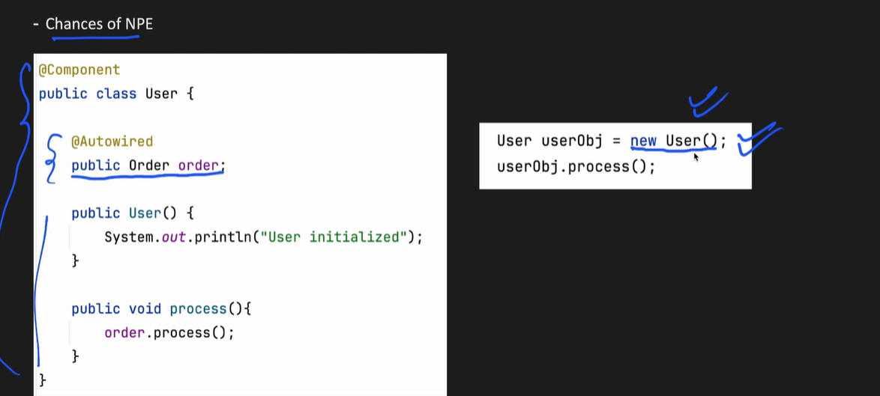

Here if we create the Manuall object of User class and try to call order class method as Order class is NULL then we will NPE (Null Pointer Exception)

## Constructor Injection:

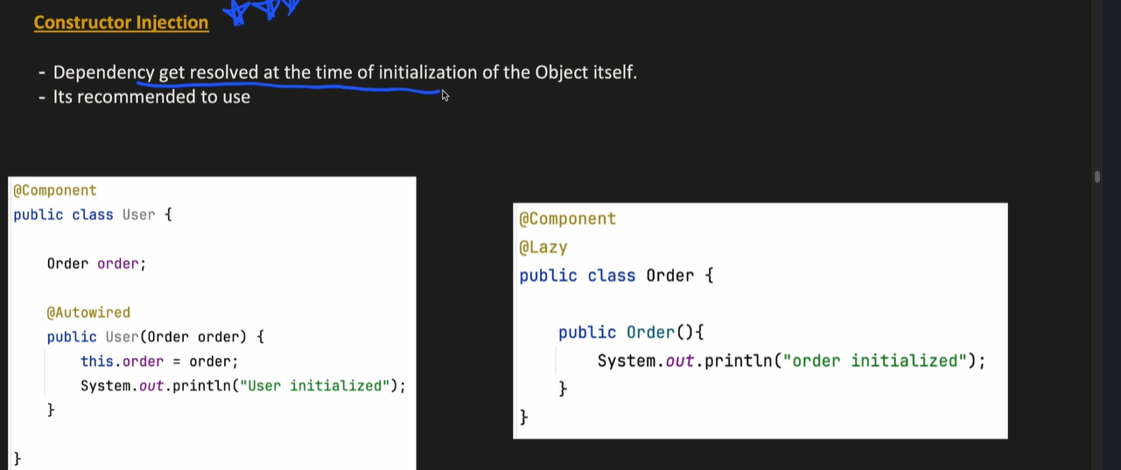

From Spring 4.3 If we have One constructor then we don’t have to use @Autowired Annotation

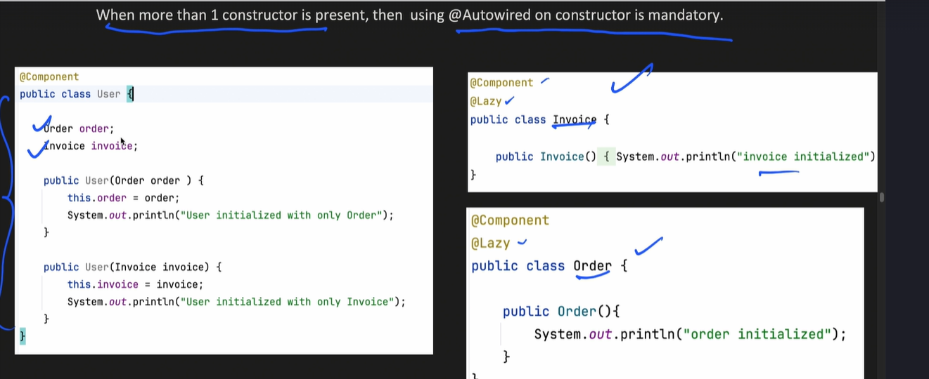

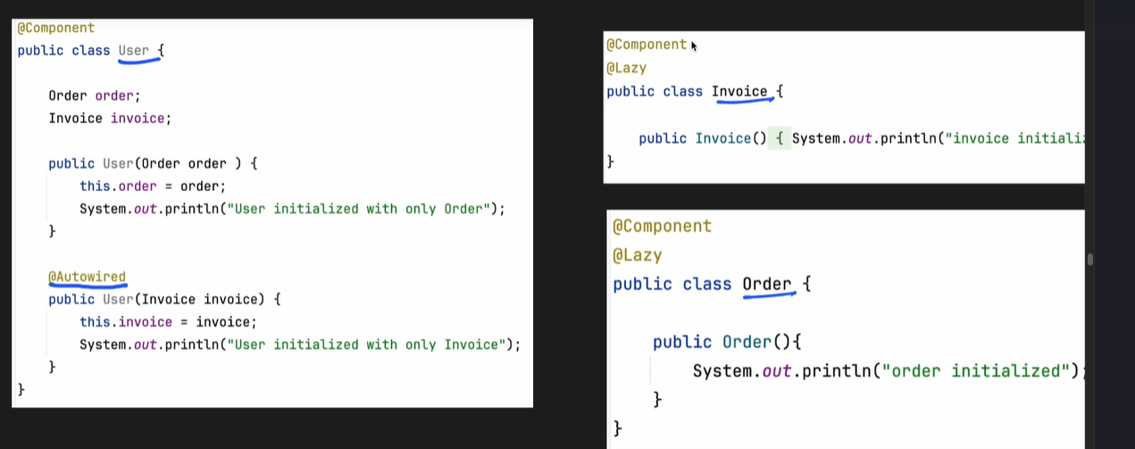

All mandatory dependency are created at the time of initialization itself Makes 100% sure that object is fully initialized

We can make our field immutable

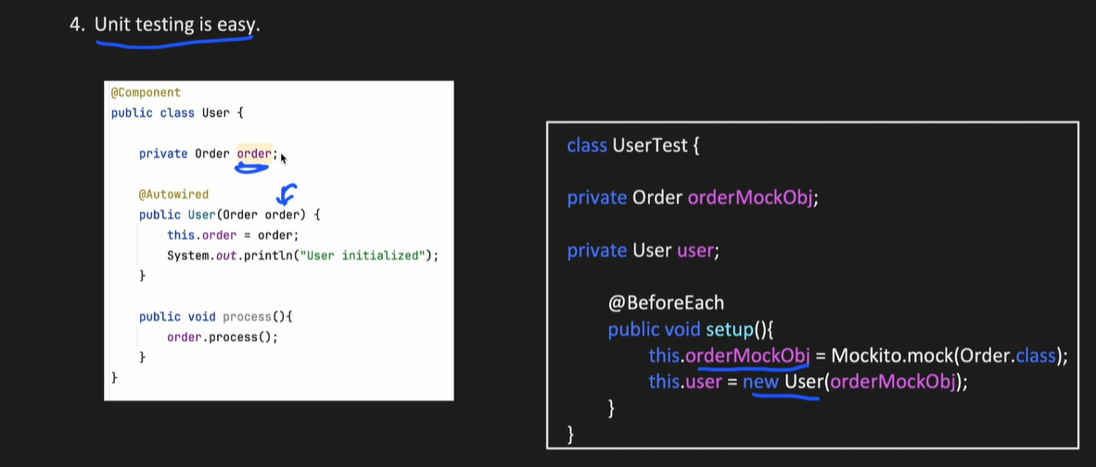

Here above image says that unit testing is very easy as we don’t have to use @InjectMock & @Mock reflections to use of dependency.

## Dependency Injection issues:

1. Circular Dependency Issues:

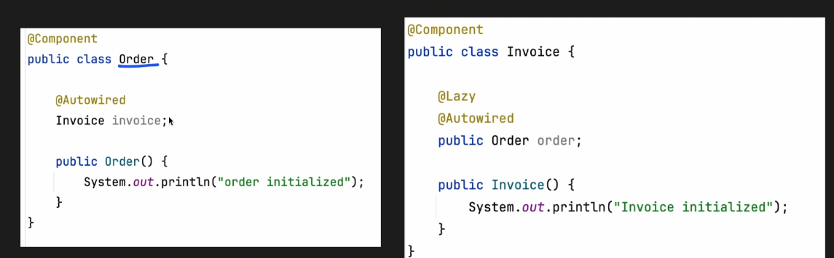

Here order and invoice classs creates a circular dependency to reolve this   
1. Either we can find out the common code and add it into the other class

1. We can annotate one of the class with @Lazy to resolve the issue

# **Spring boot : Bean Scopes | Singleton, Prototype, Request, Session Scopes:**

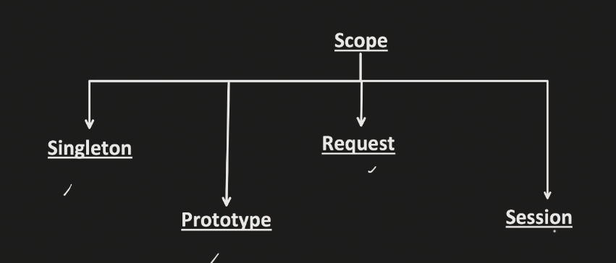

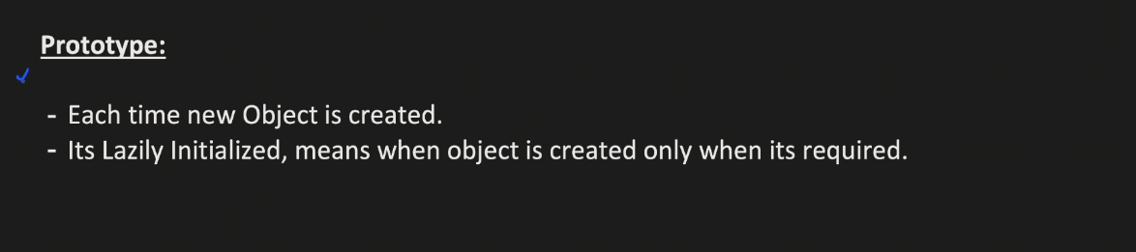

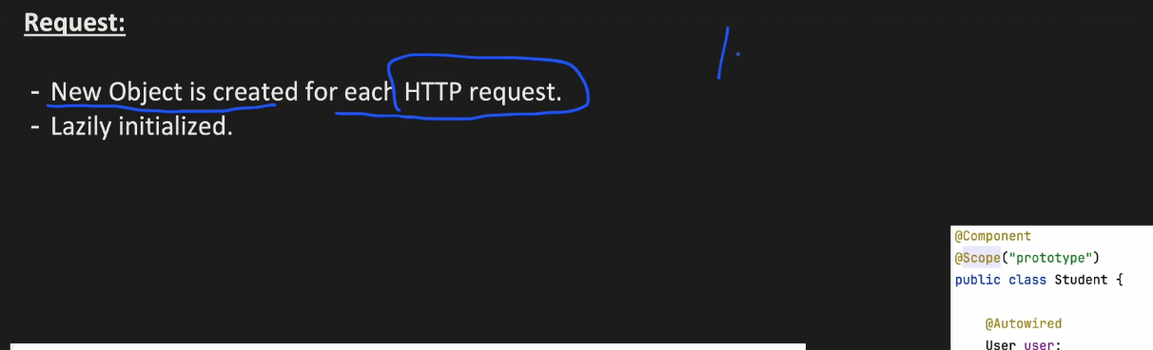

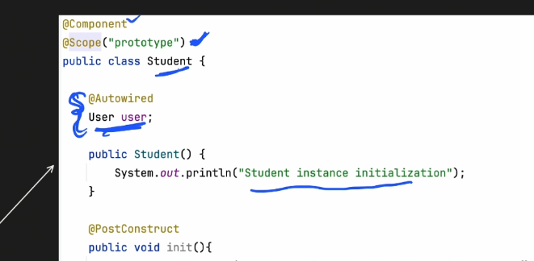

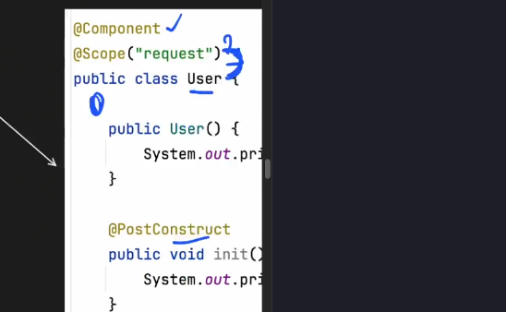

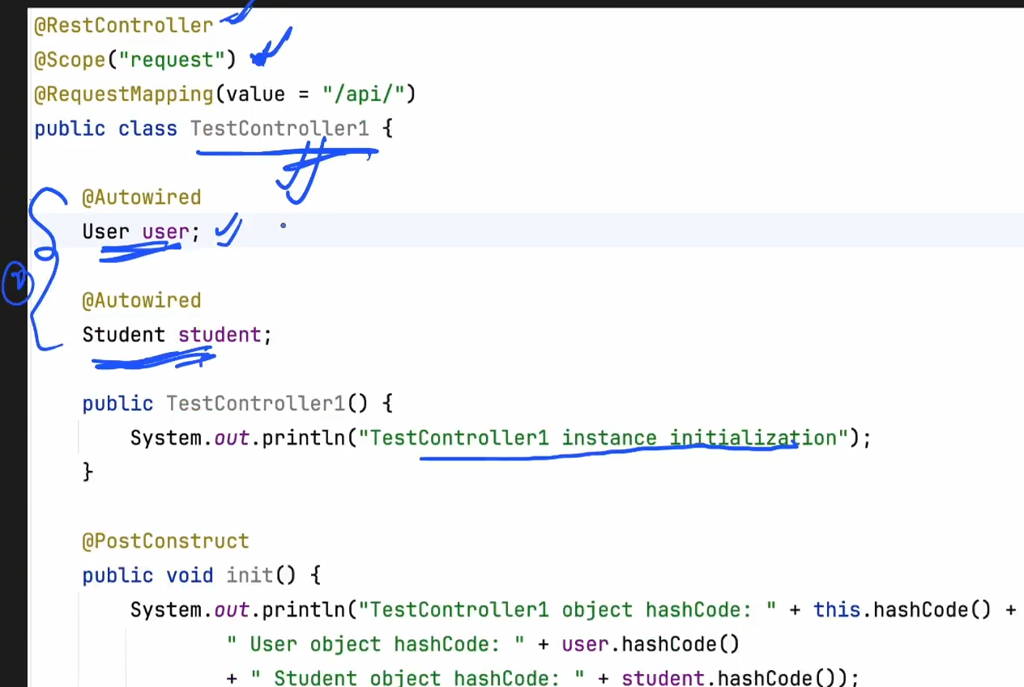

In Scope Request we have TestController with scope as REQUEST

User class Scope -> Request

Student class -> Prototype

I have a depency in testController with user and Student so in this request new obj of user & student will be created

Student have the dependency of User class but it’s a same request that need to access the user then student class will access the same user object

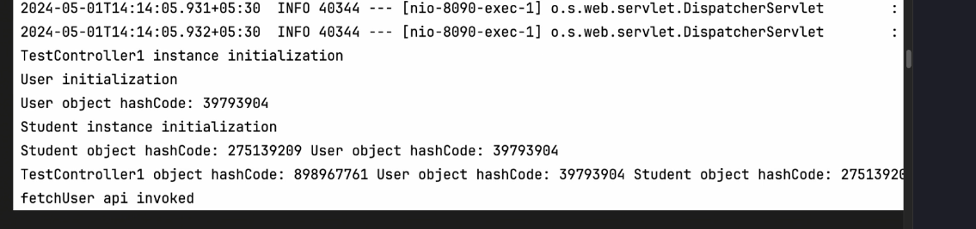

Multiple requests on same API Behaviour

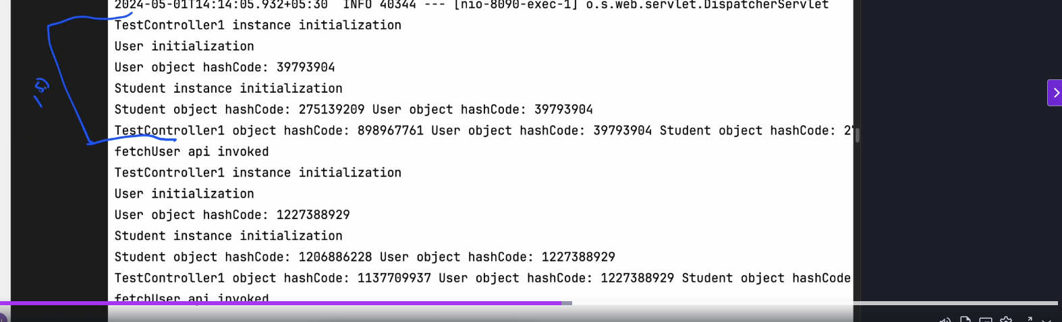

## Scenerio:

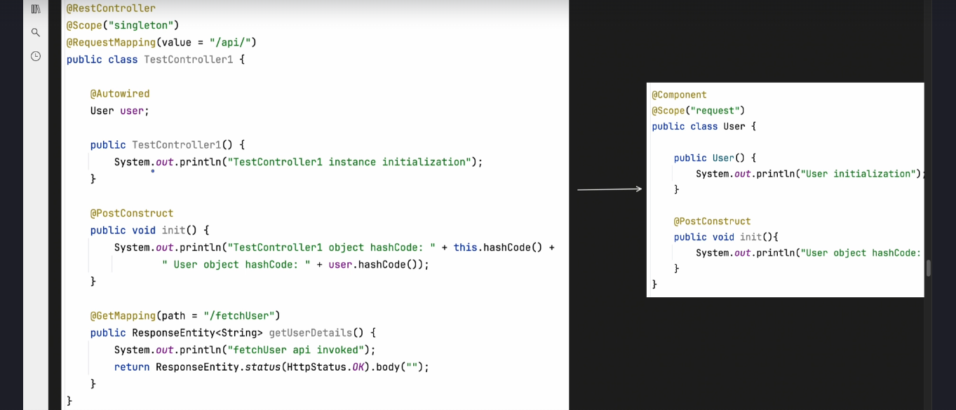

This will give error dependency injection failed:

To resolve this we need to use @Scope(value=”request”, proxyMode=ScopedProxe.TARGET_CLASS)

On user so what it will do when the eager initialization of TestController then one dummy user object will created as soon as we call the HTTP api then we have a Active request and at that time we will resolve the User class obj.

# Conditional On Property annotations

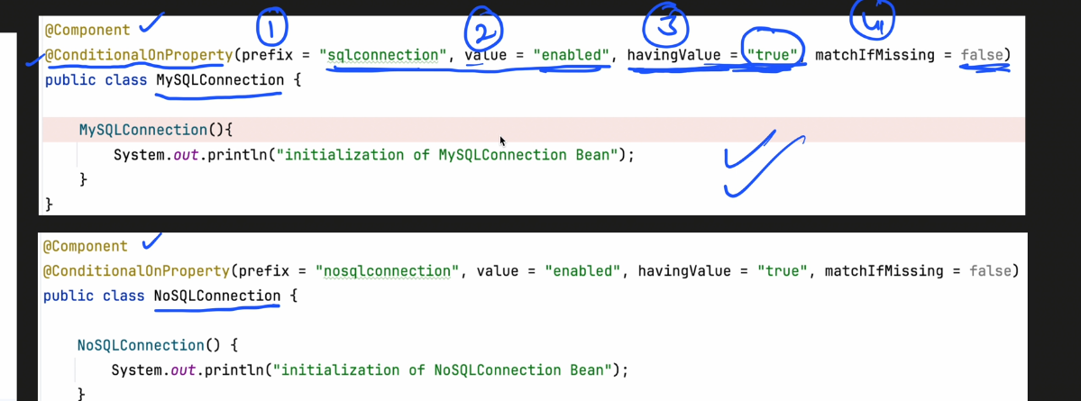

App.properites will have the key

Sqlconnection.enabled= true

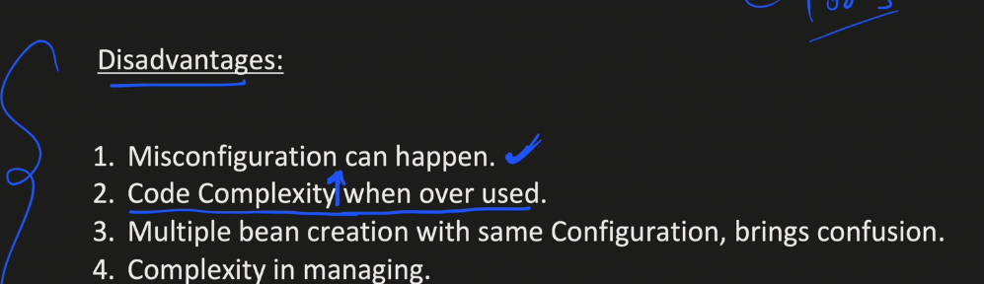

# **Spring boot @Profile annotation | How Profiling works in Spring boot**

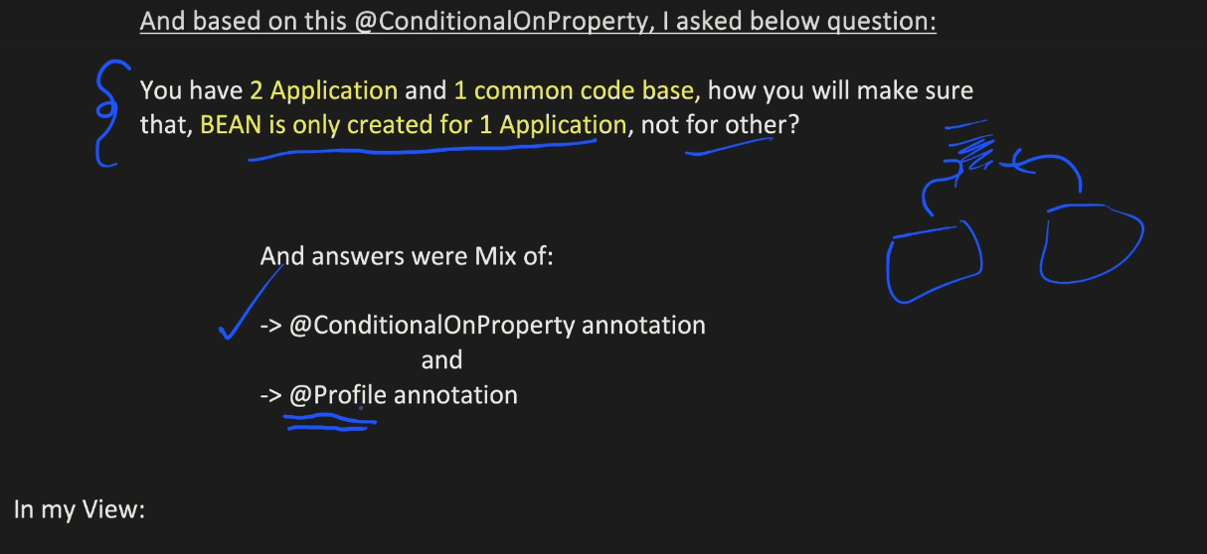

@Profile is intended for enviorment specification not for bean creation

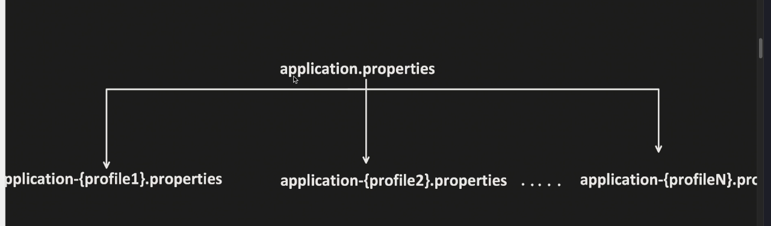

This is how we will handle the profiling in Spring boot

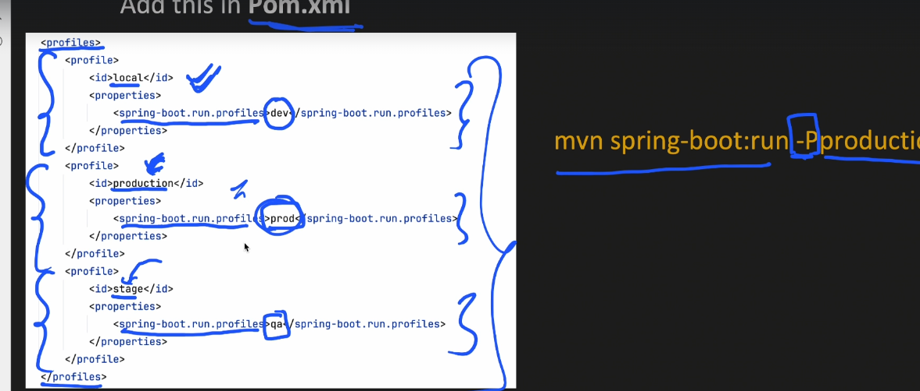

This is prefer setting in live applications

Another Command is : 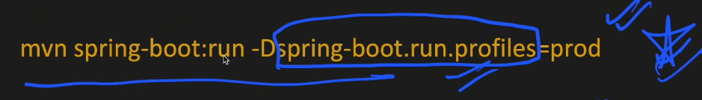

@Profile annotation tell us that if the particular profile is set then we will create the bean

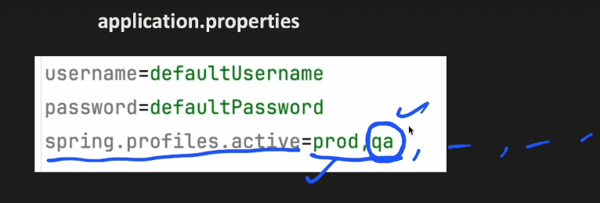

In the above image if we give multiple profile in comma separated then last one will be picked

# **AOP (Aspect Oriented Programming):**

In simple term it help to intercept the method invocation. And we can perform some task before and after

So aspect is a module which handles the repetitive and boiler plate code.

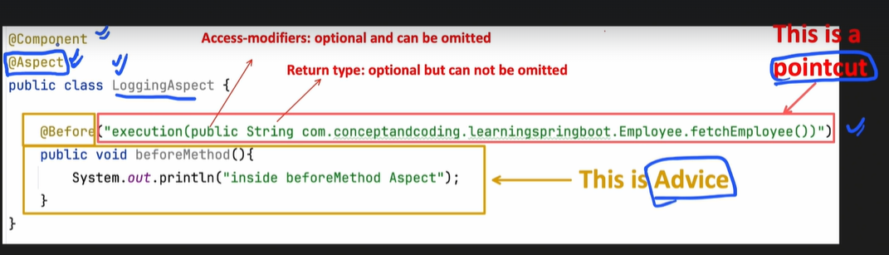

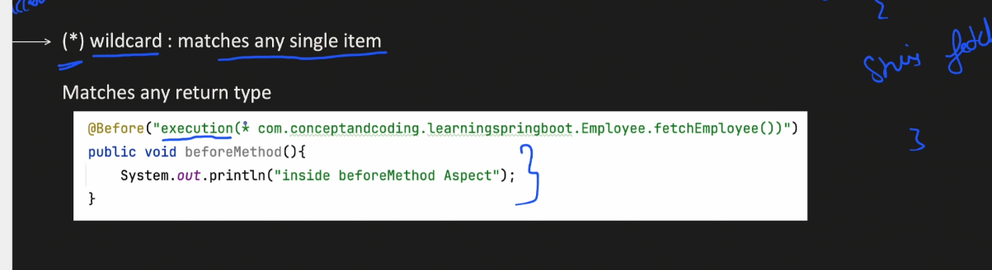

Access modifier is optional and for return type I have given then * (it will check for any type)

And rest I have given the package with methodName();

So AOP will run the advice for the given method

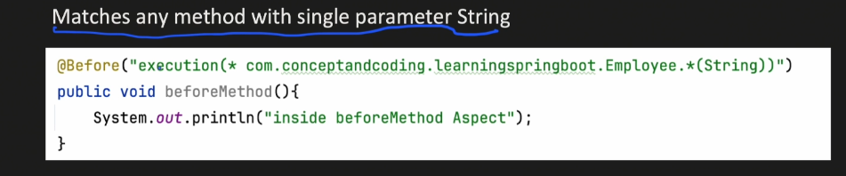

Last mein star ka means any method in that particular package

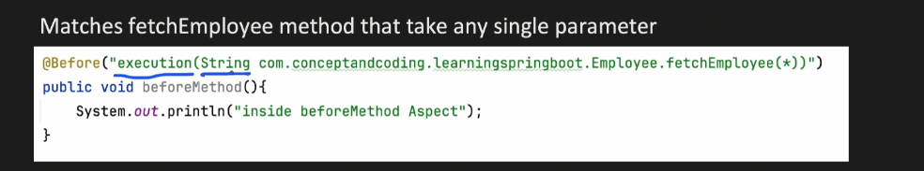

I have given the return type String and in method arg(*) we have to expect one argument will be there atleast one

1. WildCard(..)

This will match 0 or more item

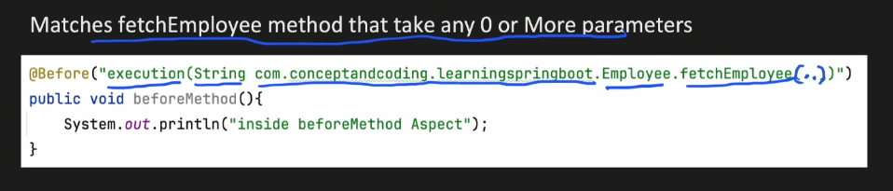

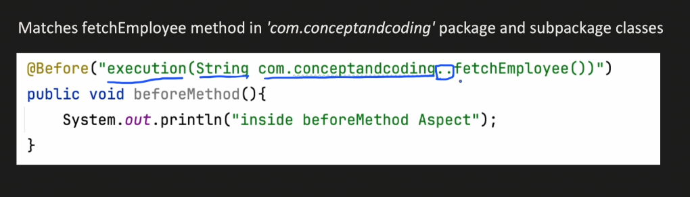

Any package and any subpackage

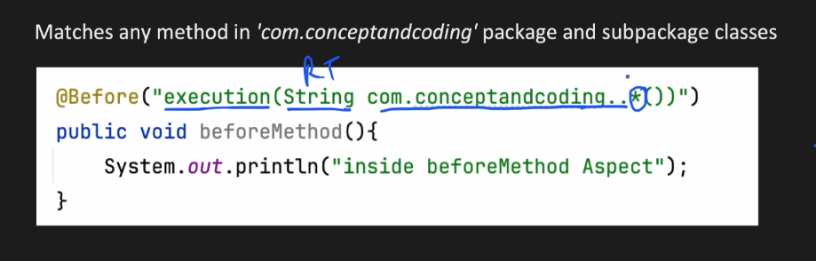

# Transactions In Spring Boot:

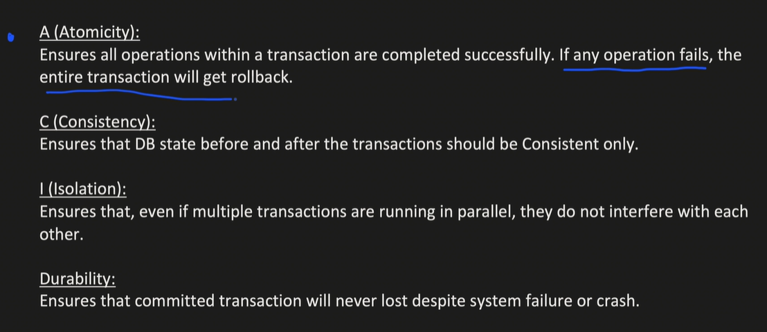

Transaction management using AOP in Spring Boot:

1. Use Point cut expression to search for method 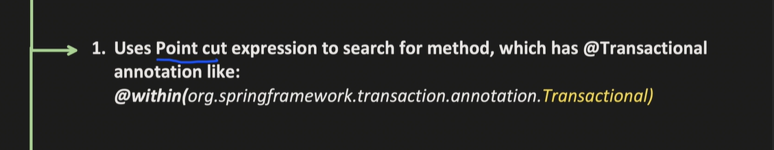
2. 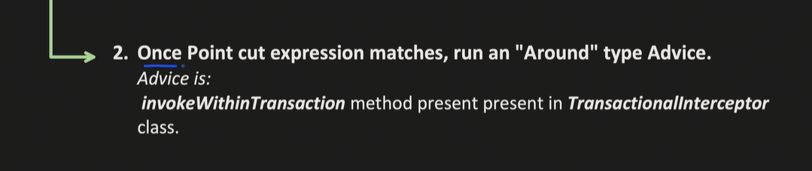

When the transaction is in running state internally it will call TransactionInterceptor class which will create the transaction or check weather we need it or not then

It will invoke the Statements of instruction we have in our code this will be done by the AOP Around point cut only first it will check for the method and transaction then it will execute the JoinPointCut then it will call the commit.

If there is some exception then it will roll back and handle the case accordingly

## Declarative programming approach & Propagations:

### Hierarchy of Transaction manager

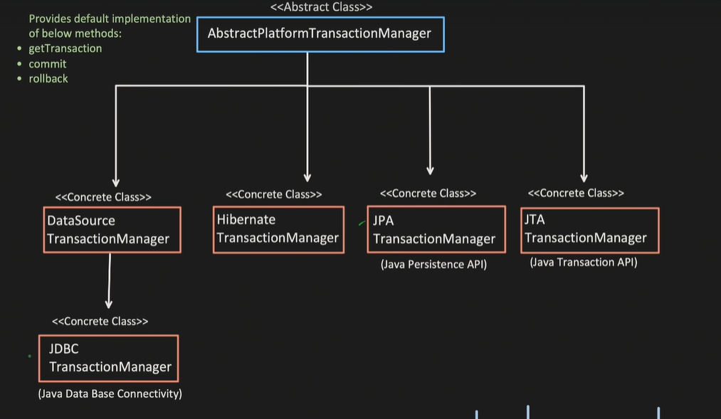

They have the method which is implemented by the concrete class over less all the implementation are of same.

Two types of transaction we have

1. Declarative -> @Transaction
2. Programmatic ->   
   I have two use @Transactional but I have to tell them which manager it will going to use then I need to write the configuration for the same

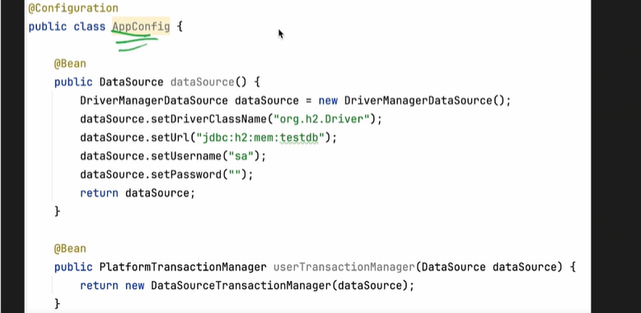

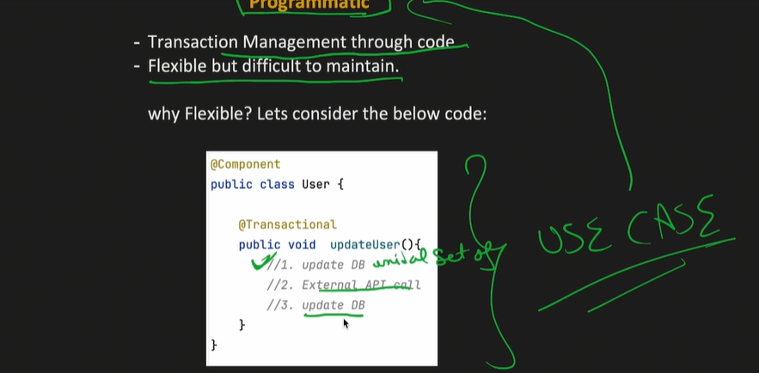

In the above image this is not a good practice, Let say we are involving the external call api and this will take around 3-4 sec then we are holding the db connection till that time

If we have a peak traffic then this will be a bottle neck problem

### 

# Approach1 to solve:

@Autowired  
 PlatformTransactionManager transactionManager;

Public void updateUserProgrammatic(){

TransactionStatus status = transactionManager.getTransaction(null);

// Steps to do

transactionManager.commit();

//In case of exception

transactionManager.rollback();

## Propagation In transaction:

When we try to create new transaction it first check the propagation value set and this will tell weather we have to create new transaction or not.

1. Required(Default propagation) 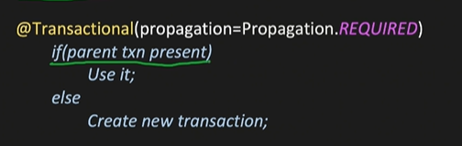
2. REQUIRED_NEW  
   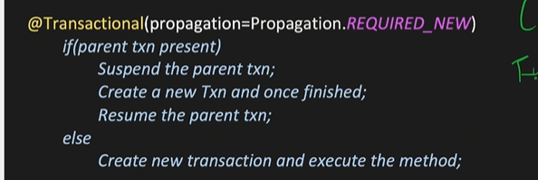
3. 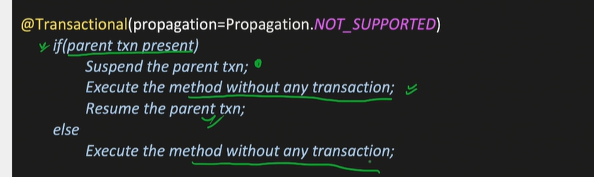
4. MANDATORY  
   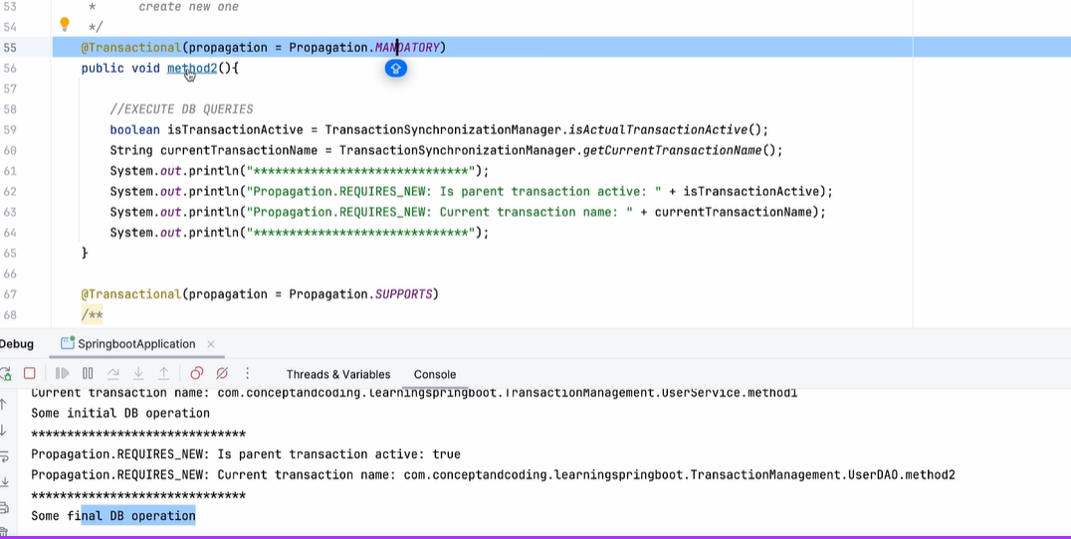

## Distributed Concurrency Control:

Many user try to book the same seat 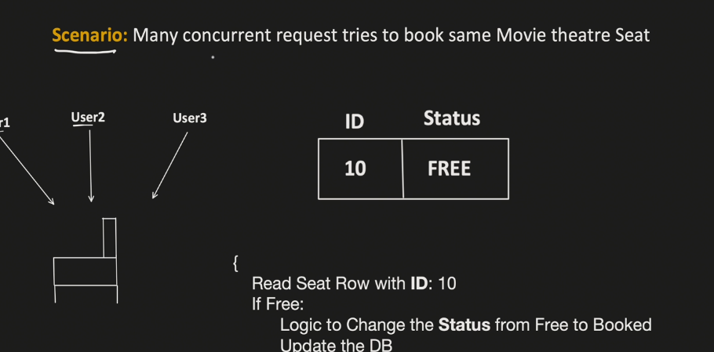

If all three able to book the same seat then there is an issue seat belongs to whom ??

We need to handle the concurrency here.

1. If we use Sychronized then at a time one user can book the seat 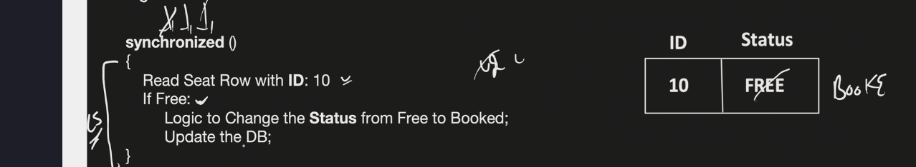
2. This will not work for the distributed system
3. One process can have multi threads 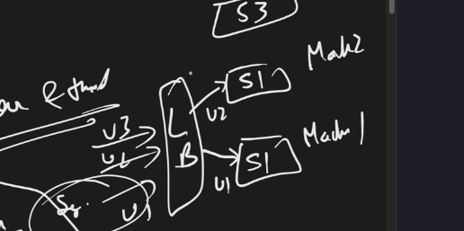

Two machines we have and through LB user are distributed to other machine then all three of them again able to book the ticket with using synchronized.

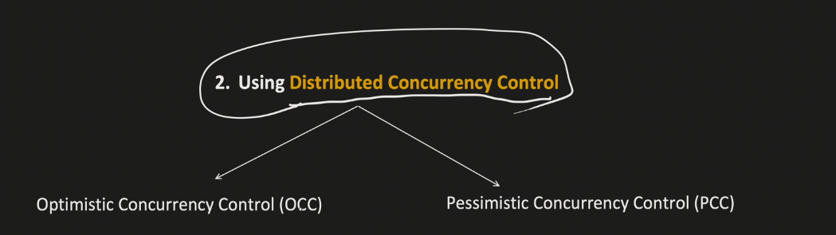

### What is the use of transactions?

It helps us to avoid inconsistency in DB.

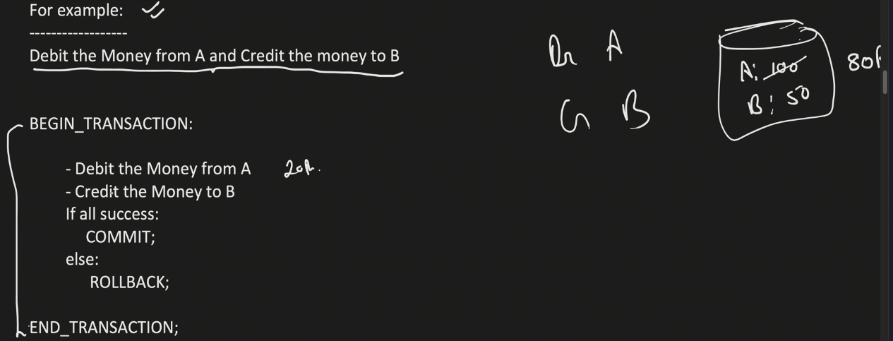

At the time of failure in transaction we can revert the changes so integrity will be maintained in the system.

# Two lock we have

* Exclusing(R/W)
* SharedLock(R);

If we have taken a exc lock on a row no other txn allows to take lock on that row;

# Isolation level present

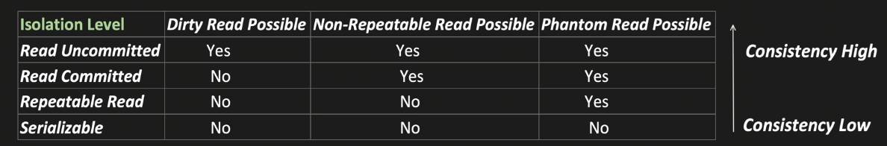

## Optimistic & Pessimistic Locking:

How optimistic handle the concurrent request ?

It maintains the column called version initial value is 0

* 2 thread want to book the ticket for movie and available ticket is one
* One thread will read the value of version and other thread also fetch the version value
* If version value will change for any thread than we will rollback the transaction with error : SOLD OUT;

